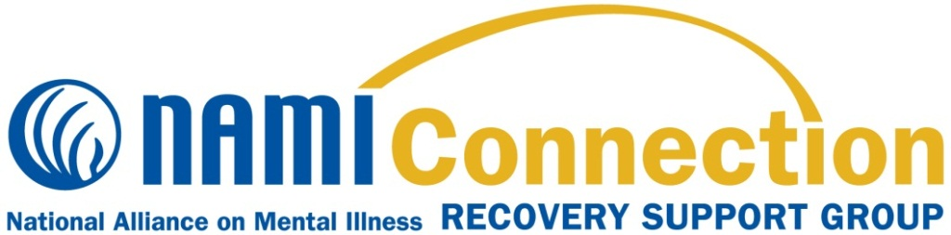

**What is the NAMI Connection Recovery Support Group Program?**

NAMI Connection is a recovery support group program that offers respect, understanding, encouragement and hope. NAMI Connection groups are:

* Free and confidential
* Held weekly for 90 minutes
* Designed to connect, encourage, and support participants using a structured support group model
* Led by trained facilitators living in recovery themselves

NAMI [Affiliate Name], the local organization of the National Alliance on Mental Illness, will offer its NAMI Connection Recovery Support Group Program for the [season] beginning [day and date]. It will be held on [days] at [time] at [location].

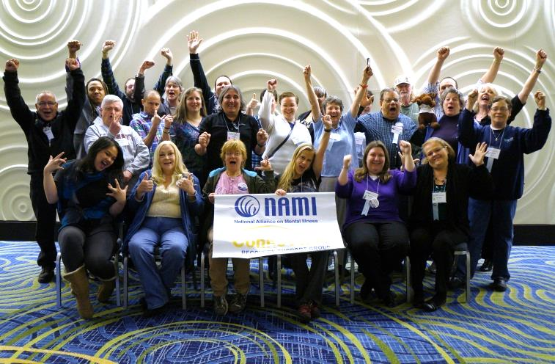

**Participant Perspectives**

“NAMI Connection has made me realize that I can truly feel comfortable around my peers and I really needed that feeling!”

“I believe NAMI Connection means hope.”

“NAMI Connection is the promise of what is and what can be in our lives.”

**Contact us to find out more about NAMI Connection Recovery Support Groups! Program!**

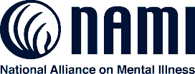

{Insert NAMI Affiliate Logo}

**About NAMI**

NAMI, the National Alliance on Mental Illness, is the nation’s largest grassroots mental health organization dedicated to building better lives for the millions of Americans affected by mental illness. NAMI {Affiliate Name} is an affiliate of NAMI {State}. NAMI {Affiliate Name} and dedicated volunteer members and leaders work tirelessly to raise awareness and provide essential education, advocacy and support group programs for people in our community living with mental illness and their loved ones.

**{Contact Name}**

**NAMI {Affiliate Name}**

**{NAMI Affiliate Address}**

**{NAMI Affiliate City/State/Zip}**

**{NAMI Affiliate Phone Number}**

**{NAMI Affiliate Email}**