Accessing NAMI Smarts on NAMI.org

- Go to www.nami.org and select NAMI Leaders on the upper-right hand side of the website.
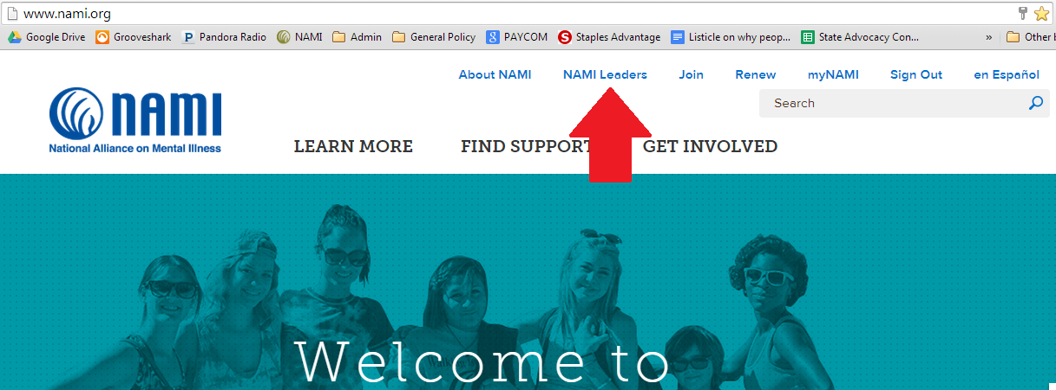
- Click on Go the “NAMI Extranet” Now.
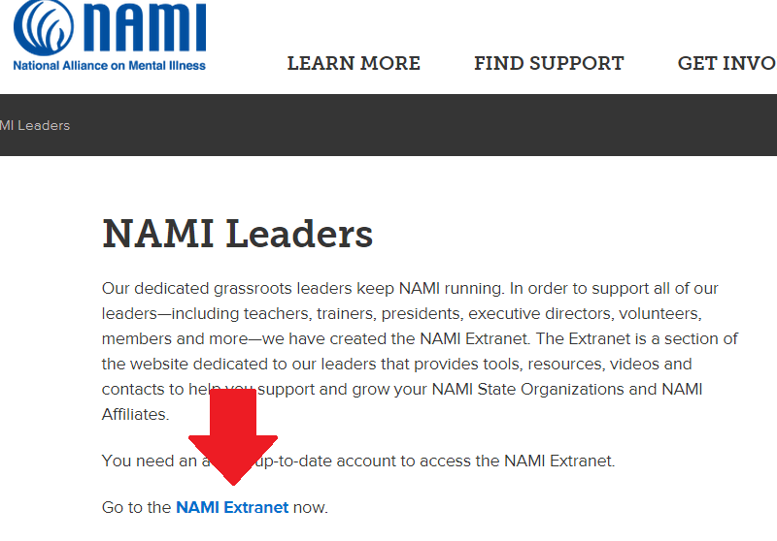
- Sign-in to your www.nami.org account. (if you receive a message saying access denied, email jwhart@nami.org)
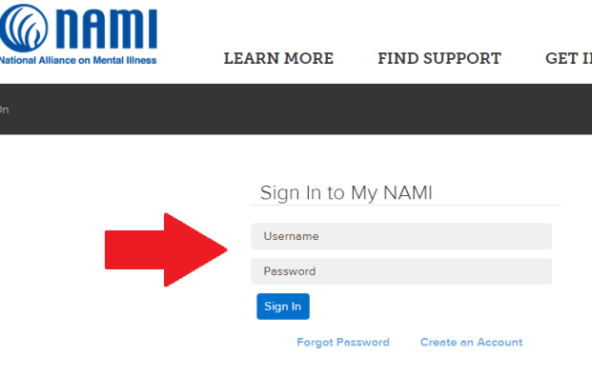

- Select “Education, Training and Outreach Programs” “Get Started” button.
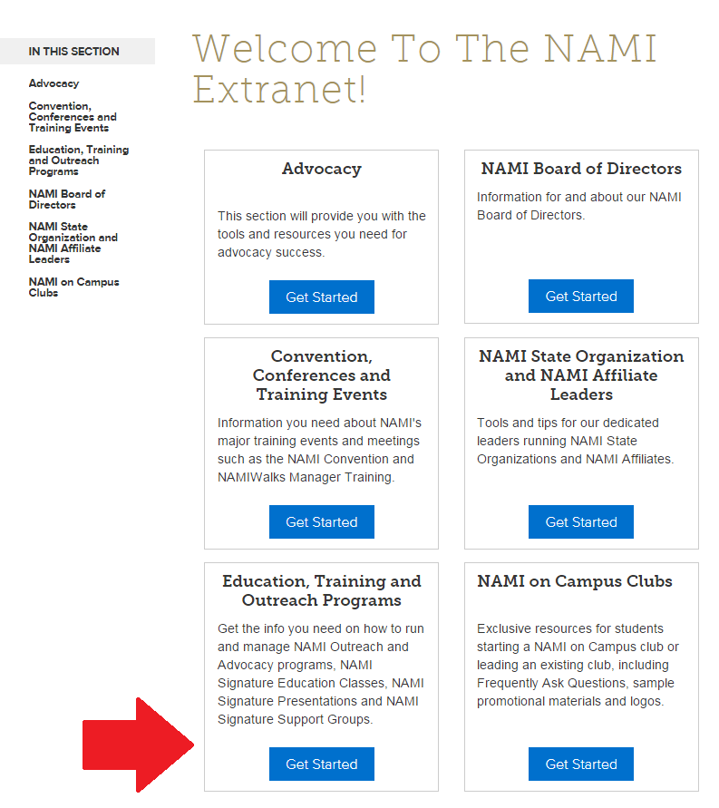
- Select “NAMI Smarts”
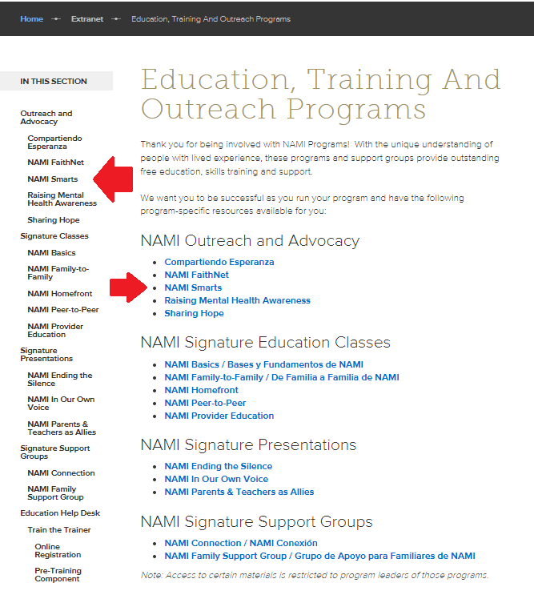

- Here is all the NAMI Smarts Materials. You can click on the grey box to the right to report your data or you can go to www.nami.org/namismartsleaders.
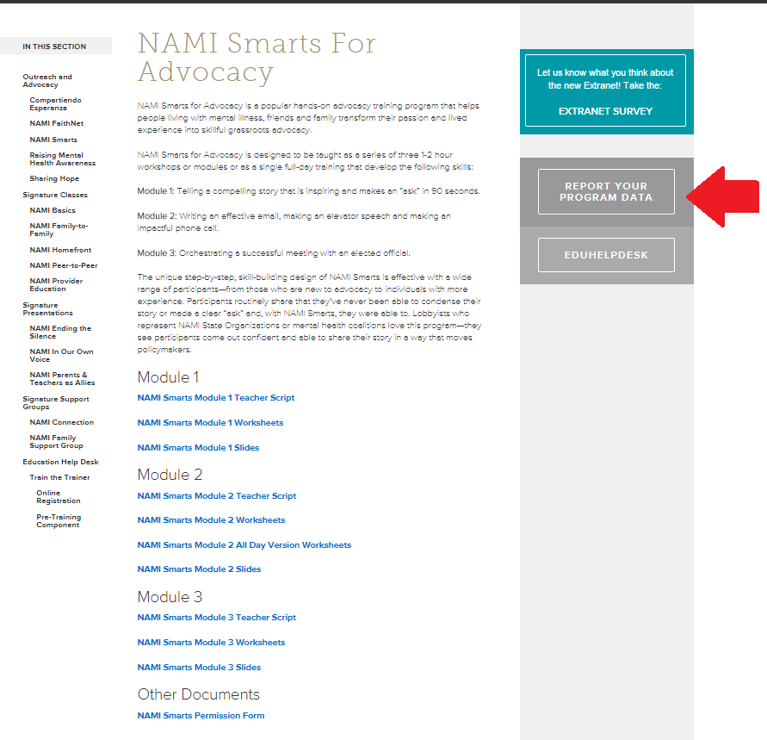
- Report your data.
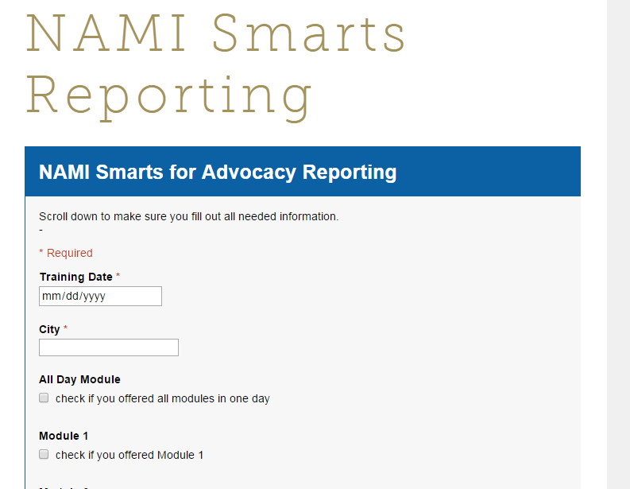

OR, use the data reporting SHORTCUT – no username or password!
- Go to http://www.nami.org/programdata
- Click NAMI Smarts for Advocacy
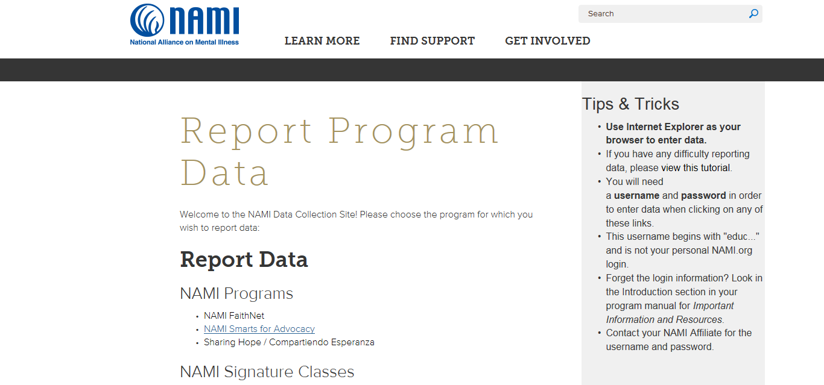

- Complete the form. Remember to SCROLL DOWN!
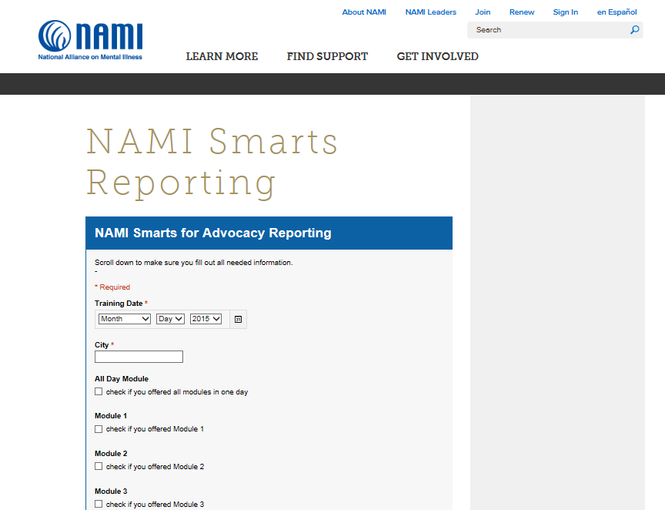

- Complete all prompts. Click “Submit”
- When you see this screen, you’re done!
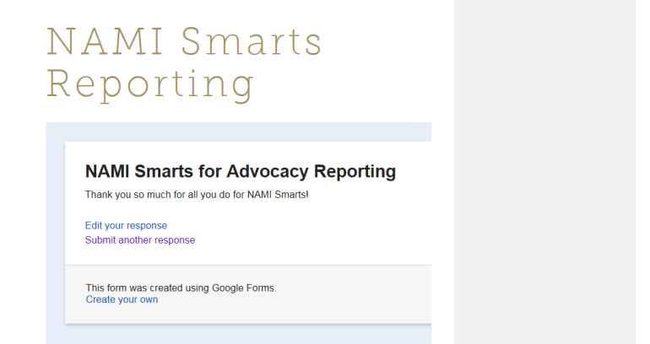

Thank you for teaching NAMI Smarts for Advocacy!

